Luke Norris - United Kingdom, English

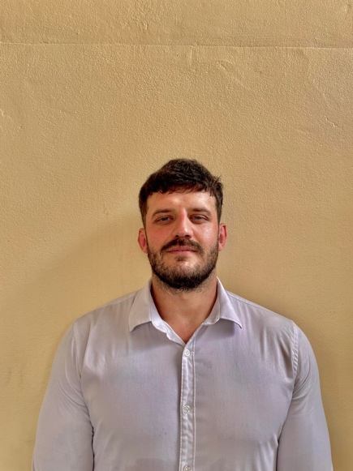 |  | Malteser Lane, Sala Kamreuk, Siem Reap, Cambodia 17000
 |  | 07745712033
 | □ | Lukechaynorris@gmail.com
 | Z | Zoom - Lukechaynorris@gmail.com ID - Luke Norris

PERSONAL STATEMENT
Teaching in Cambodia is a dream come true. I’m very passionate about working with young people. It’s something I’ve been doing since leaving the royal marines and I can honestly say I love it. Showing people what they’re capable of has always been very rewarding to me. Using my skill set and life experience I know I can play a huge role whilst making a difference.

EDUCATION & TRAINING
Rainhill High School
GCSEs - English. B
- Maths: C
- Science: C
- Art: B
- Music: C
- Physical education: B
140 hour TEFL/TESOL course, Destination TEFL onsite in xxxxxx (www.destinationtefl.com) TEFL Qualification – 140hr in class, with observed teacher practicums

March 2023

2003 - 2008

TEACHING EXPERIENCE

Nov 2021- Feb 2023 | Commando Jo’s. Role: Elite Commando  - My role as an elite commando was to travel to different Schools round the northwest of England to deliver our respect programme  - This programme was made to help children use their imaginations whilst building team working skills and developing confidence  - I worked with children from the age of two, all the way up to eleven.
Feb 2021 - Nov 2021 | MPCT. Role: Training Instructor  Location: Wrexham/Manchester  - My role at MPCT is similar to Evolve, instructing and mentoring young people to achieve their goals, whether that be to enter the Armed Forces or the world of work  - I work within the Schools programme of the company, teaching students aged between 13-16  - I work closely with the local schools and councils to update them on the students progress within MPCT. Some of my responsibilities at MPCT are planning and delivering classroom based lessons, to ensure the students are on target to achieving their qualification in:  - City and Guilds: Level 1 and 2 Award in Employability Skills  - City and Guilds: Level 2 Extended Certificate in Employability Skills  - Pearsons BTEC: Level 2 Extended Certificate in Teamwork and Personal Development in the Community
July 2020 - Feb 2021 | Evolve Military College, Military Physical Trainer/Mentor  Location: Wigan  - My role at Evolve was to inspire, motivate and mentor young people to realize their potential. Helping them to develop key skills for entry into the Armed Forces and the world of work, utilizing my personal knowledge, skills and experience gained through Military Service  - Contribution to the design & delivery of safe, effective & inclusive Physical Training sessions  - Plan and delivery of basic military knowledge, skills and fieldcraft sessions  - Compliance to all relevant health and safety regulations, including adherence to company health and safety, and safeguarding policies and procedures  - Timely completion of qualifications and units delivered, ensuring awarding body specifications and standards are met  - Maintaining a professional relationship with stakeholders to ensure current contracts are renewed and to positively promote the company's service.
May 2023 - present | English teacher Australian Centres of Development (ACD) Cambodia, Sisophon.  - I'm currently an English teacher at ACD school, working with all ages ranging from age from five to mid thirties.  - I also teach all levels from First Friends to let's go Vocab which is heavily based on vocabulary.  - My other levels include Incredible English, Headway and Pathways National Geographic were Students Reading, Writing, Listening, Grammar and speaking is tested throughout the term.  - I also have experience in IELTS were Students are tested at their highest capability.
WORK EXPERIENCE
Jan 2018 – Dec 2019  Aug 2015 – Aug 2016  Mar 2009 - Dec 2017  17 September 2012 -  April 2013 | XERCISE4LESS, Personal Trainer  Location: St Helens  - As a Personal Trainer, I was responsible for exercise advice & personalized training for clients on a one-on-one basis, developing a fitness program to meet the specific needs of the client and for ensuring that equipment was used appropriately and for the desired purpose
LUKE NORRIS COMMANDO FITNESS
Location: Rainhill
- Military style bootcamp I ran as a side project. The class was for all levels and ages, which was beneficial for me as the clients I was working with were aged between 14-55; therefore, I worked to accommodate these age groups
- My classes promoted and encouraged teamwork, providing a fun & friendly atmosphere and to gain self-confidence
- Feedback from clients was positive, claiming that it was fun, and exercising outdoors was a great way to reduce stress and anxiety
ROYAL MARINES COMMANDO
Location: 40 Commando, 45 Commando and Afghanistan
- After 32 weeks of intense military training, I passed out as a Royal Marine Commando. Firstly, I was based in Scotland as a Rifleman
- After spending two years here I moved to the driver’s unit in Taunton for another two years before being deployed to Afghanistan. When I returned from my 7-month tour I trained to become a Mortar Man and moved back to Scotland
OPERATION HERRICK, Deployment to Afghanistan
Location: Helmand Province, Afghanistan
- The objective of the tour was to win the ‘hearts and minds’ of the local population in partnership with the Afghan National Police (ANP) and Afghan National Army (ANA)
- I utilised my experience and Commando training by taking personal responsibility for a number of tasks including the training of ANP / ANA colleagues in base security, vehicle / person search and check point drills
- Throughout our vehicle checkpoints, part of our objective was to use detection dogs to sniff out any drugs or explosives within the vehicles
- This interaction developed my understanding of cultural and behavioral values in a high-risk operational environment which assisted in understanding the mindset of the local population and enemy insurgents
- During the tour I took part in a number of operations including:
  - Intelligence Gathering: Daily patrols into high-risk areas where I reported on issues that provided valuable information and intelligence to support the overall tactical objectives of the battle group
  - Fighting Patrols: Day and night-time fighting patrols to disrupt / deny enemy insurgent activity within the Province
  - Valuable experience gained through extended periods of deployment in hostile environments

ADDITIONAL SKILLS
NVQ Level Three Health & Social Care, 2017
Level Two Gym-based Exercise:
- MMA Fitness, Kettlebell, and Indoor Cycling Instructor: 2015
- Level Three Person Training: 2015
- Level Three Diploma in Exercise Referral: 2015

HOBBIES AND INTEREST
REFERENCE
I like my fitness and going to the gym, walking my dog, cooking, watching films & socializing with my peers.

Dale Prescott - Regional Manager Commando Joe’s Prescott.d@commandojoes.co.uk / +44 7931757895
Willie van Loggerenberg – Operations Director, Siem Reap Head Office, Cambodia info@destinationtefl.com

