- It is often the case that you work and teach at the same time, and here it should be possible that you do not write the end date but only the Present. this means the person is still working there and cannot write an end date.

Examples: Aug 2010 - Present

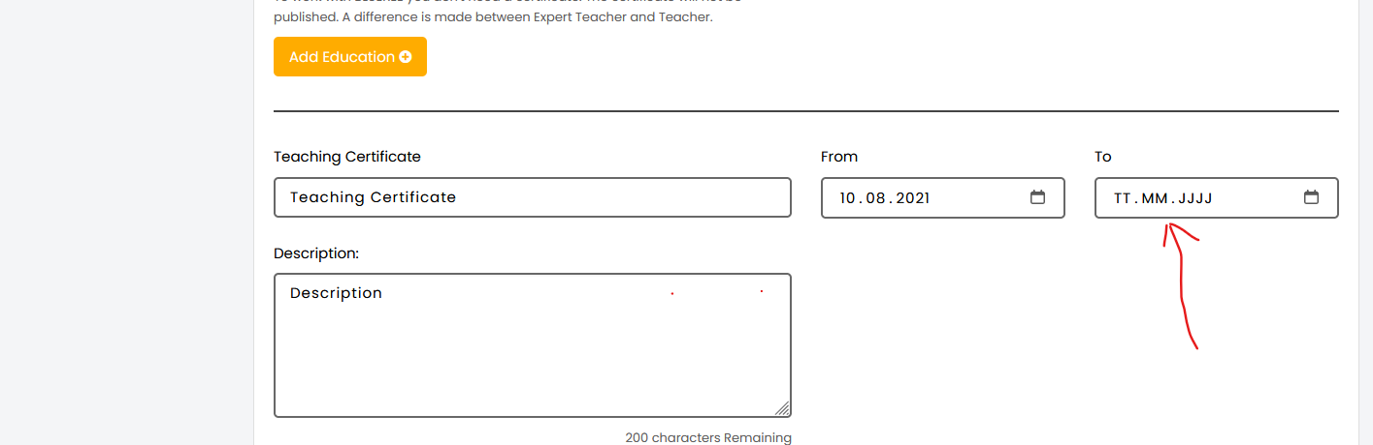

2. I had also complained about this point several times, that we should do hacking via the admin panel here or it shouldn't be here, but if we set the hacking via the admin panel and it appears in the profile under find a tutor

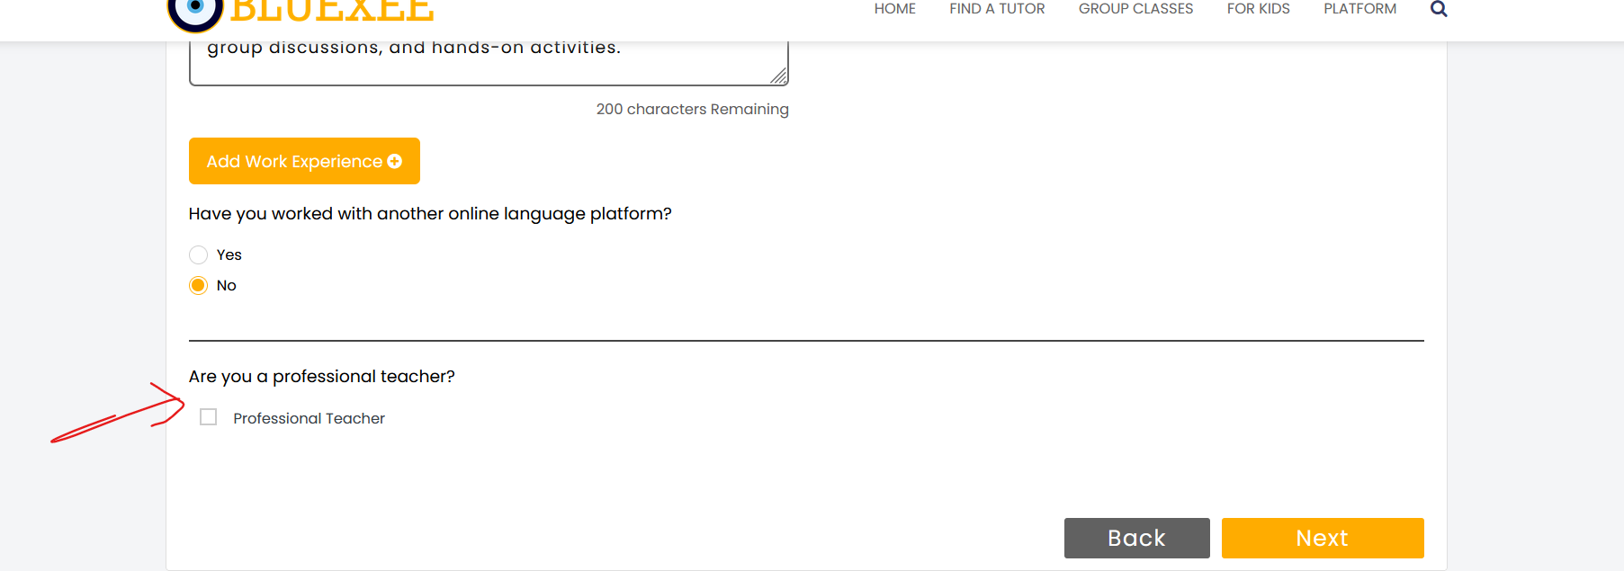

3. Upload profile photo unter Become a Tutor, there should be a zoom option here so you can zoom in on the photo or zoom in from afar. I also sent you a video for it in the past.

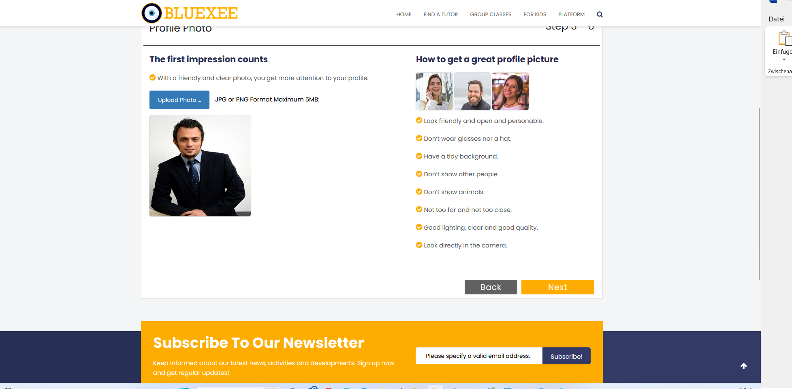

4. it looks like Certicate Verified is set up automatically here, the idea was that when we verified it we should tick the admin panel and it should appear here. If it is not possible then please delete this part for Work Experience just for WOrk experience and not for Educations
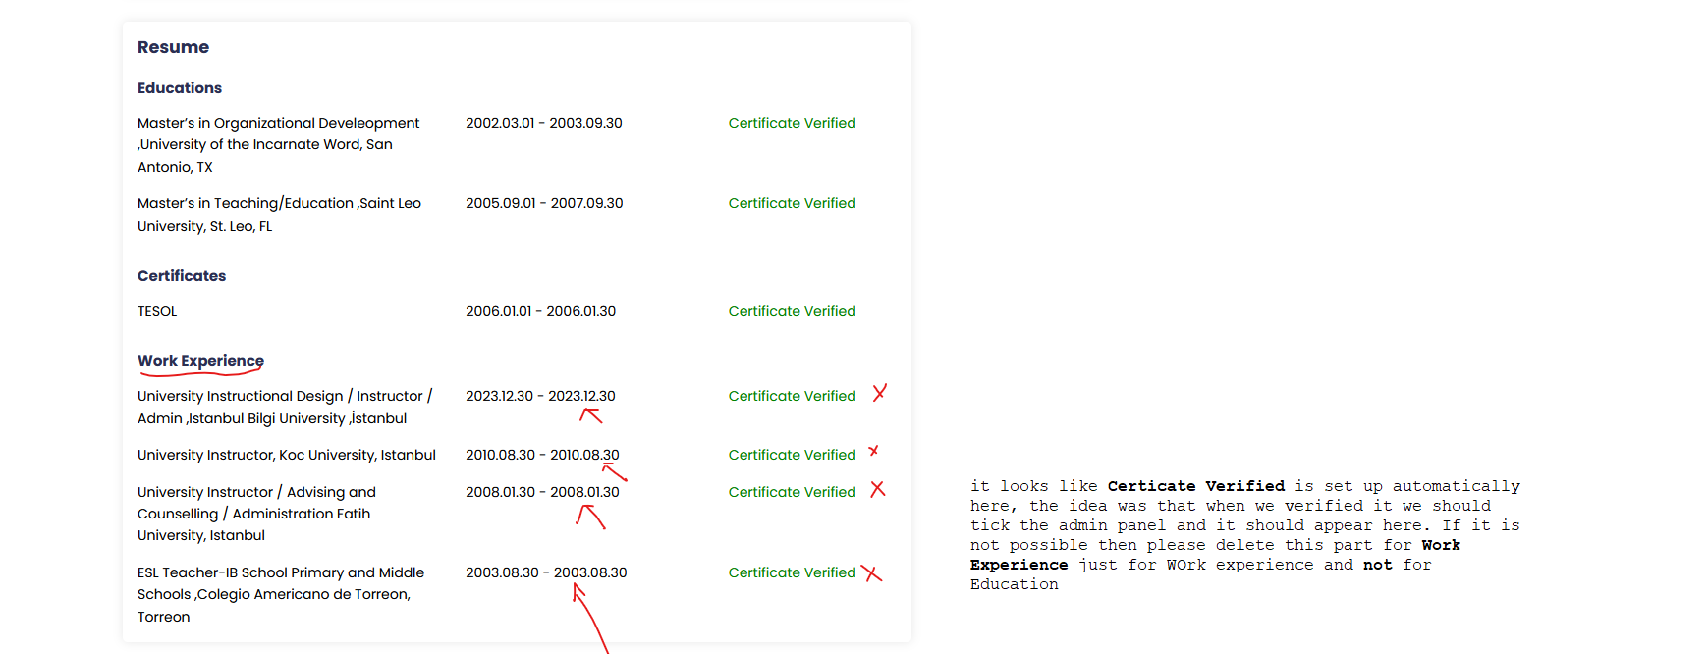
5. how is it here if you want to add a language afterwards, it wouldn't be bad if you can add and add here afterwards.

