* Registration page was down:

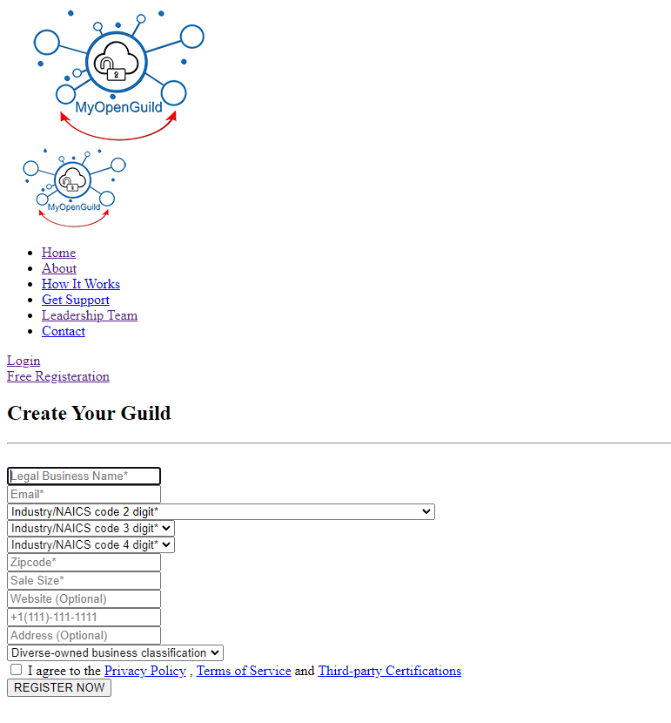

* Remove up/down arrow in zip code cell in registration form

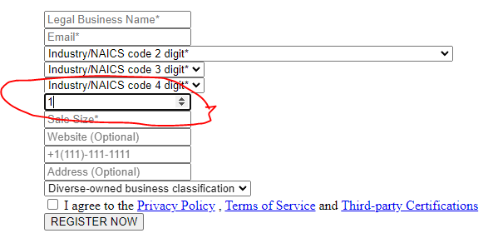

* Add to invite form company name next to email address:

Company name

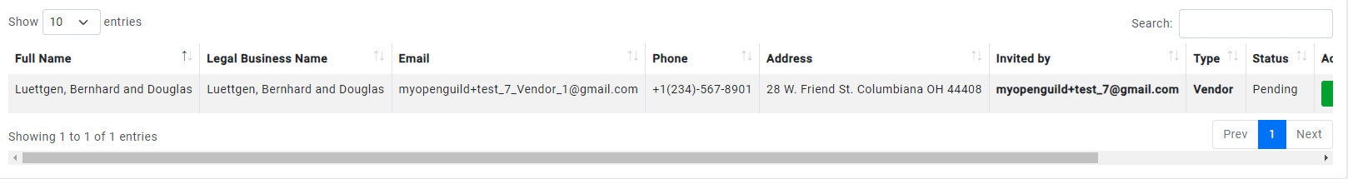

* Failed to appear as normal

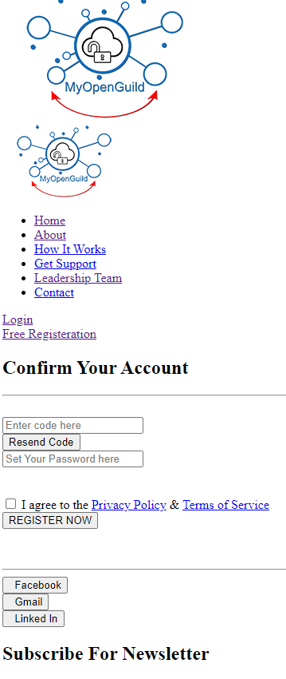

* Invitation said that “Bruen-Ryan Added you as Vendor in Myopenguild”

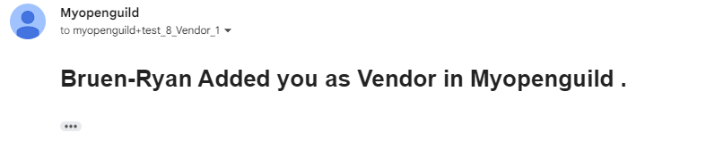

* + It should be instead – “Haley, Mante and Lesch” added “Bruen-Ryan” as Vendor (or as Client) to his business network in Myopenguild.
  + **Inviter** added **invitee** as a client/vendor to his business network in Myopenguild.com (I believe we discussed that change before)
* Connection shown for all “Connected” and “Connect” (not connected options)

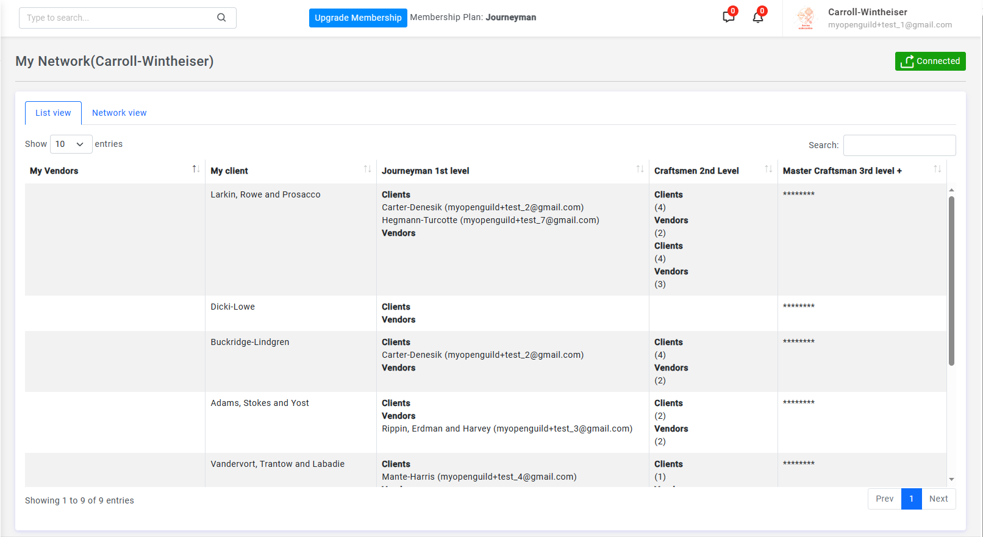

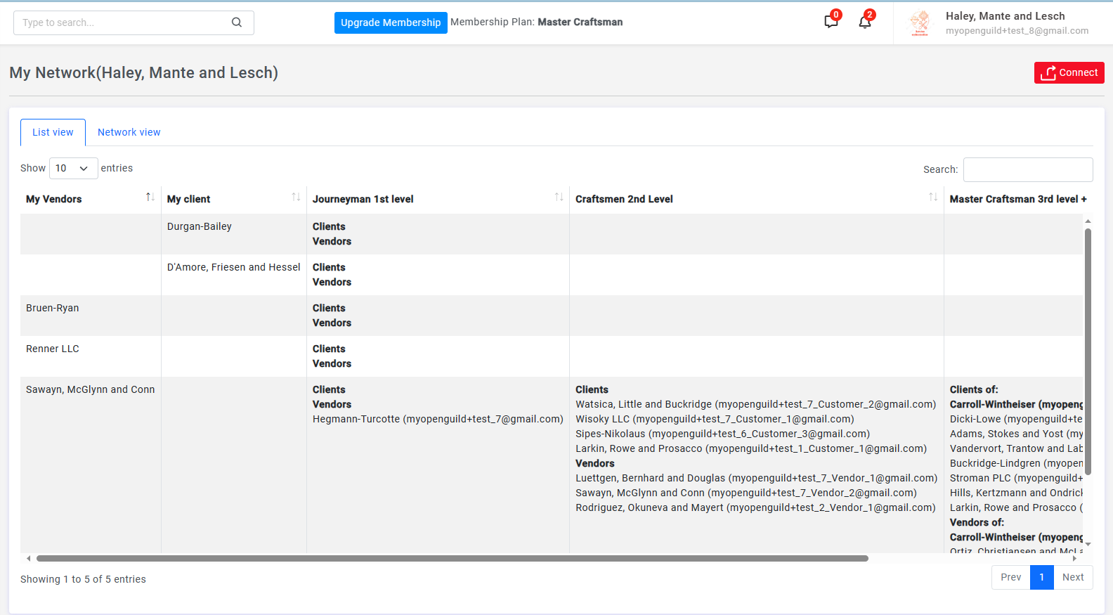





* Mail comes in horizontal forma and it hard to read:

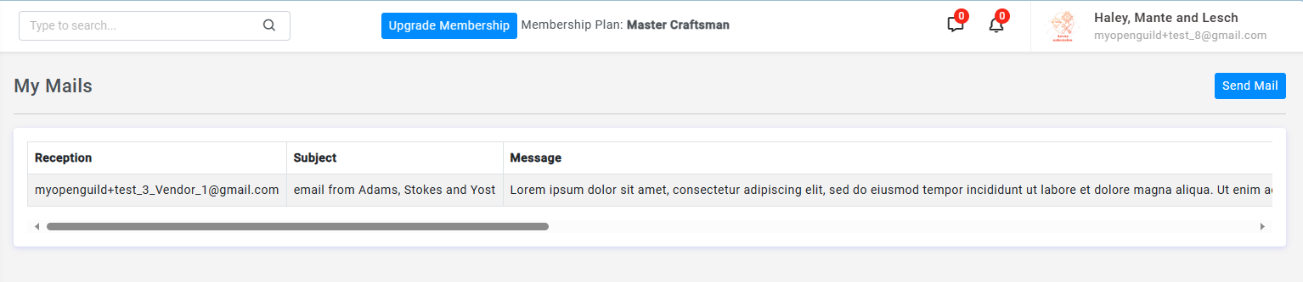

* No attachment option available for email
* Cookie acceptance not in new version of site. For reference shown old site below:

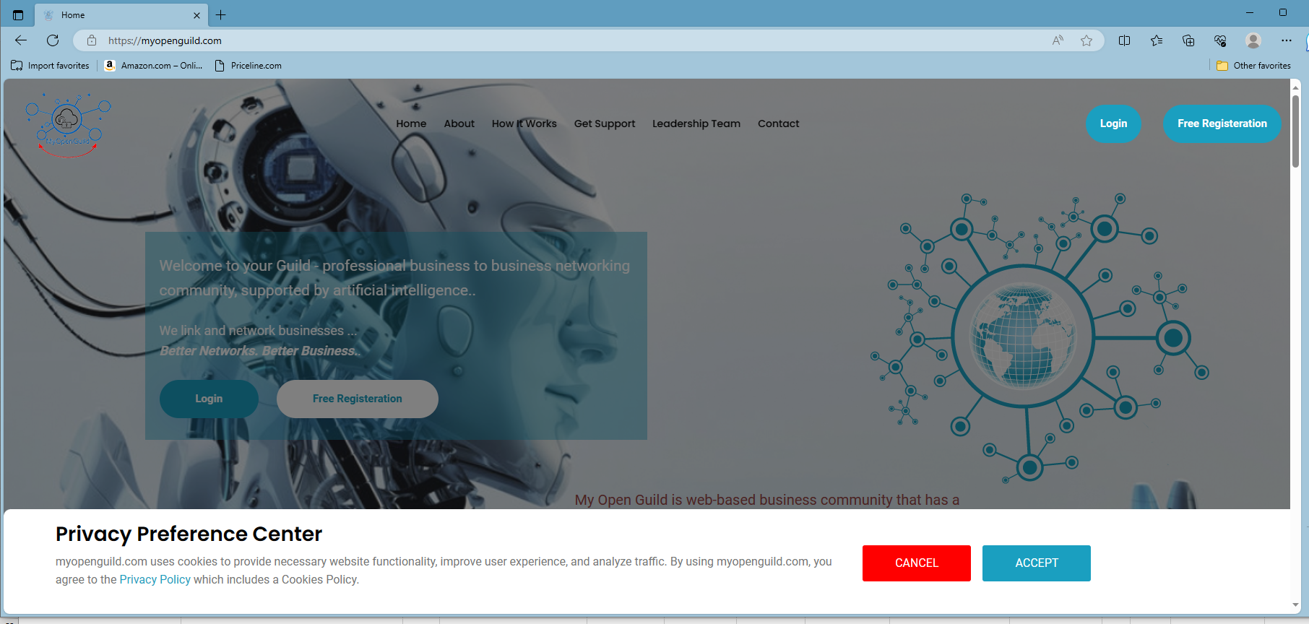

* My tools some of the working and some not. It looks like if single tool present under icon it works fine and multiple tools under icon are not leading to the folder with links:

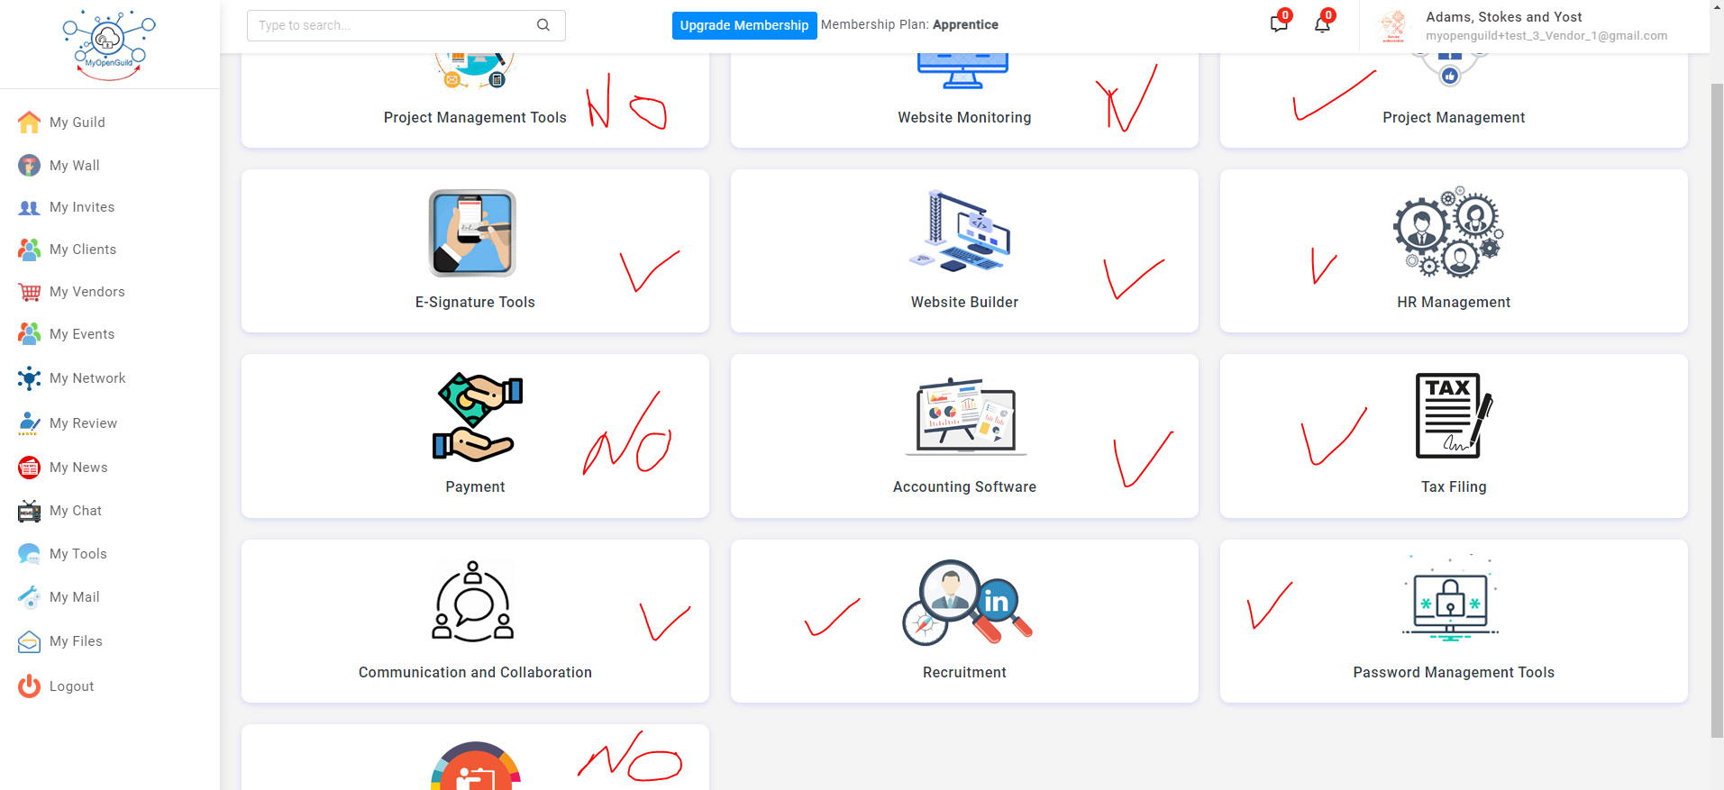

* Not sure if chatroom is working